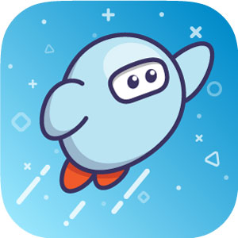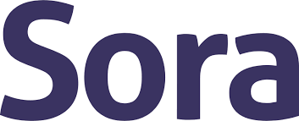
Borrow free ebooks and audiobooks!

https://soraapp.com/library/wswhe
Select Galway Central School from the drop-down menu
Students have to follow the prompts to use their school Google login. For the username, it’s their “Gmail” address. The password is the 4-digit lunch code and Gcsd (ex. 1234Gcsd). No spaces.

Q: What is Sora?
A: Sora is an ebook/audiobook platform, for borrowing books, that is AWESOME. It was created by Overdrive and replaces the old Overdrive platform. For anyone who uses the Libby app for public libraries, Libby and Sora are close cousins.

Q: How do I/How does my child access Sora?
A: If you are on a Chromebook or PC, you can go to https://soraapp.com/library/wswhe to get to Sora ebooks.
If you are on a Smartphone, tablet, or other device that can access apps, get the free Sora app!

Q: My child downloaded the Sora app. Is this safe?
A: Absolutely. These are library ebooks and audiobooks. There are no ads, and no personal information is shared with anyone.

Q: What if I don’t have consistent wifi at home?
A: You can download an ebook or audiobook and play it “offline”. Yay!

Q: I just checked out an ebook. Can I listen to it, too?
A: Sora has three main kinds of titles. Most of the ebooks are just like opening a physical book. The audiobooks are listen-only. There are “read-alongs” (which are together in one collection) which allow you to listen and follow along at the same time.

If you have any questions regarding Sora, feel free to ask your librarian!
aederwin@galwaycsd.org

